Monitoring Task

Task Description:

Install Prometheus and Grafana on a Linux EC2 machine, connect Prometheus to Grafana, and create a dashboard to view metrics.

Techstacks needs to be used :

- AWS EC2
- Prometheus
- Grafana
- Node Exporter

AWS EC2 instance (Amazon Linux):-
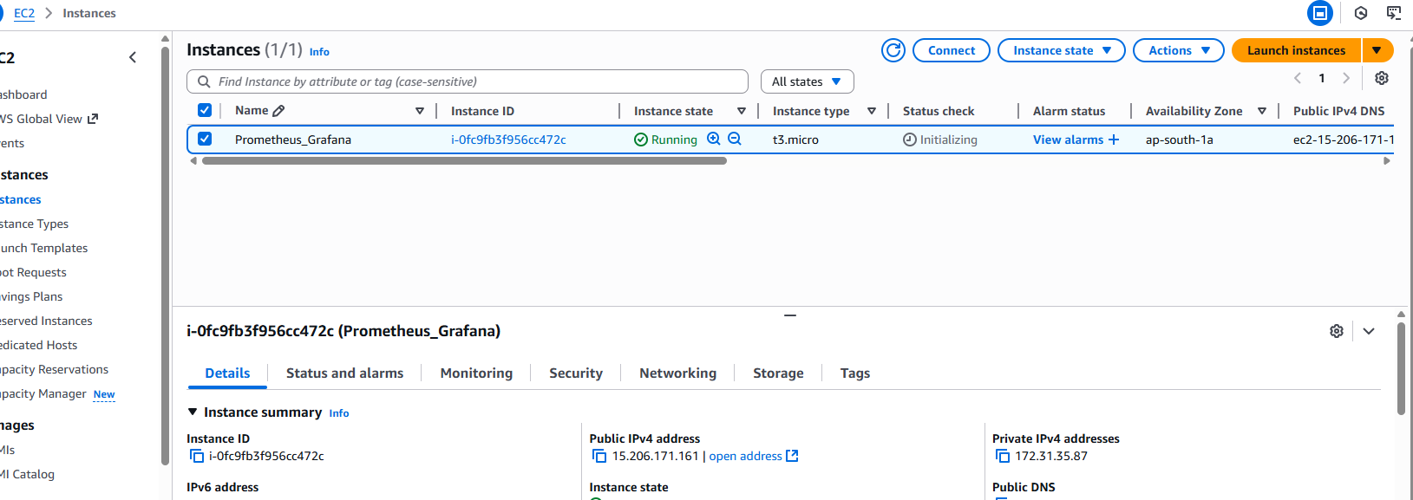
Security Group Required Port are Allowed:
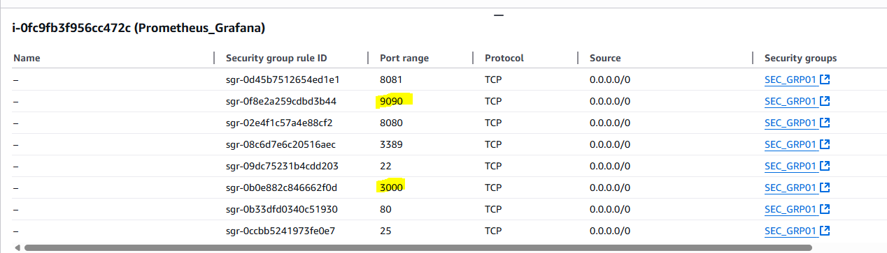
Installed Prometheus on EC2 instance:-
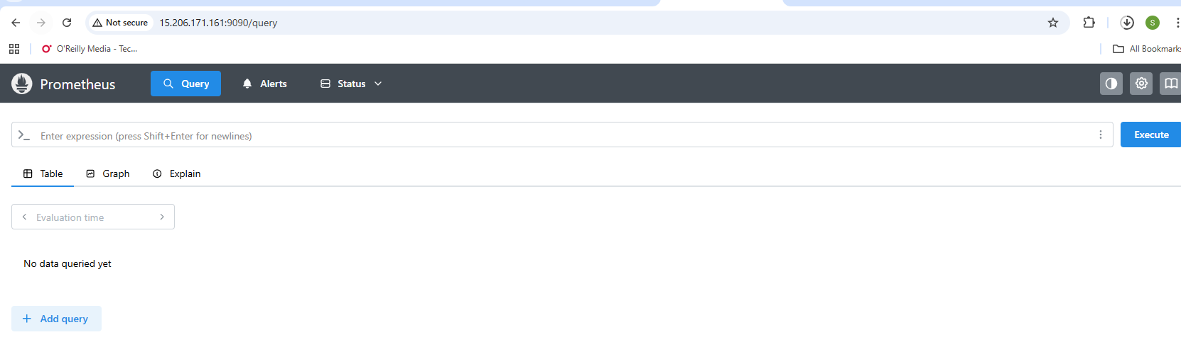
Installed Grafana on EC2 instance:-
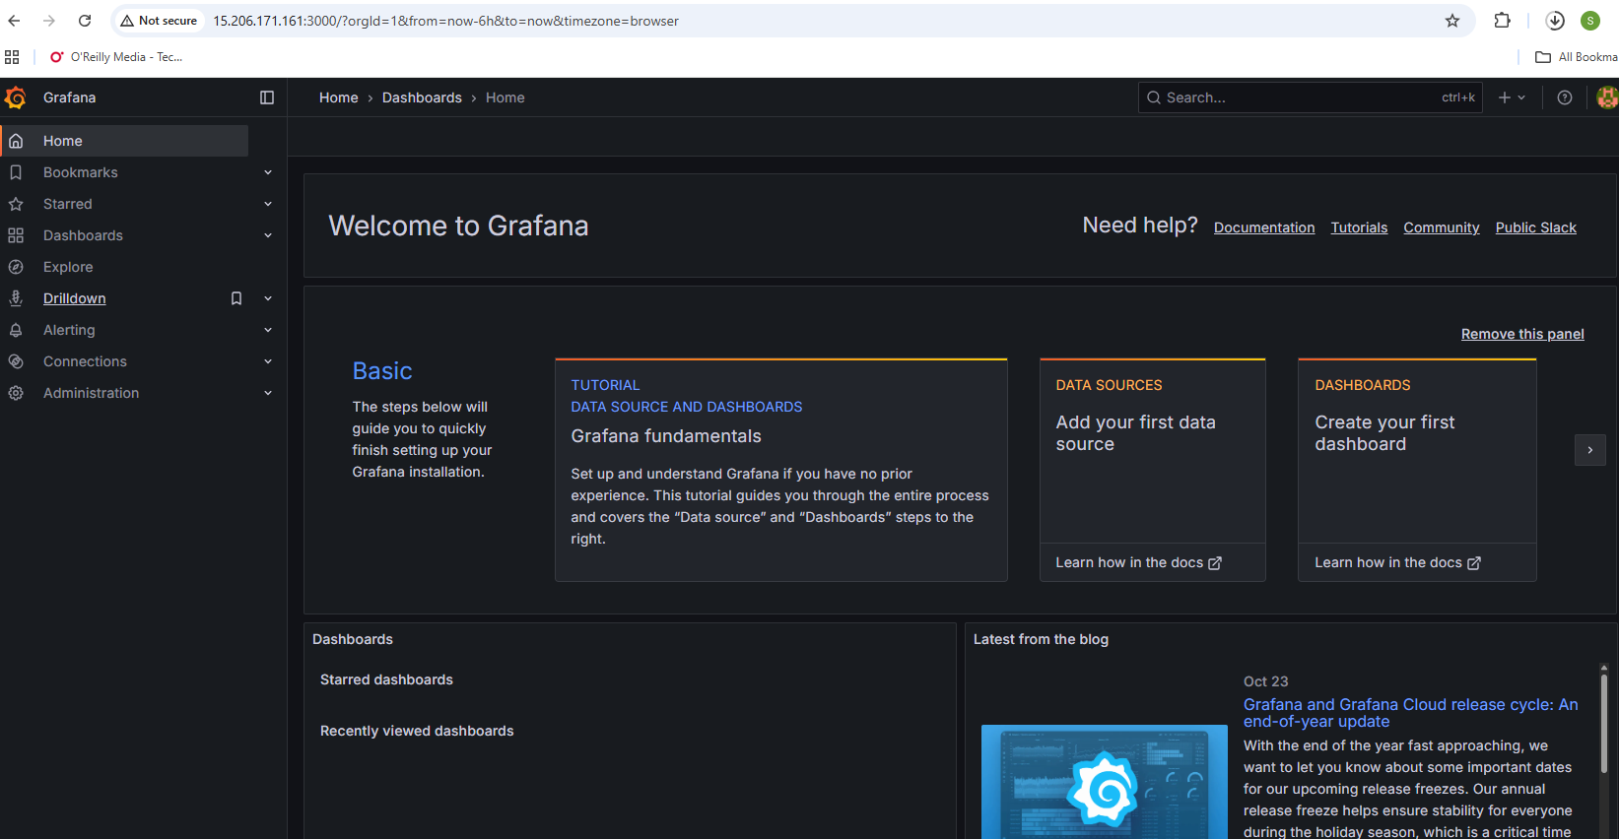
Connected Prometheus to Grafana:-
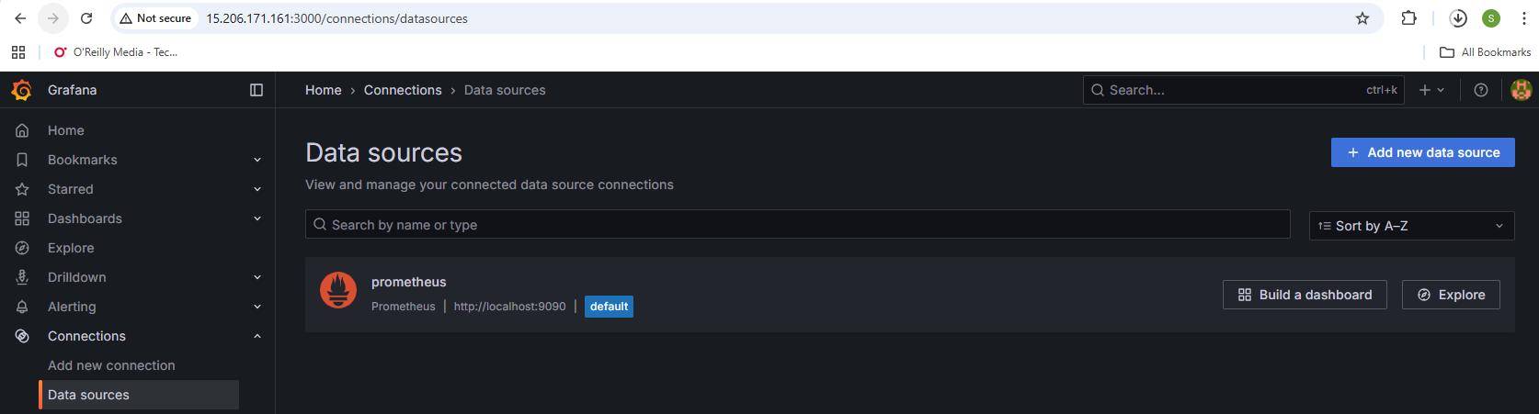
Created a Grafana Dashboard:-
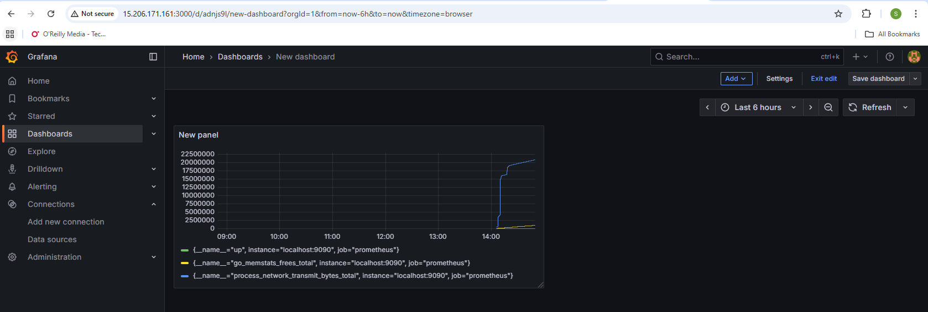
Connected with Node_Exporter:-
